**PIZZA SALES ANALYSIS SQL QUERY**

1. **KPIs**
2. **Total Revenue**

**SELECT SUM(total_price) AS TOTAL_REVENUE FROM pizza**



1. **Average Order Value**

**SELECT SUM(total_price)/COUNT(DISTINCT(order_id)) AS Average_Order_Value FROM pizza**

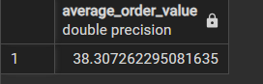

1. **Total pizza Sold**

**SELECT SUM(quantity) AS Total_Pizza_Sold FROM pizza**



1. **Total Orders**

**SELECT SUM(quantity) AS Total_Pizza_Sold FROM pizza**



1. **Avg. Pizza per Order**

**SELECT SUM(quantity)/COUNT(DISTINCT(order_id)) AS Avg_Pizza_per_Order FROM pizza**



1. **Day trend for Orders**

**SELECT TO_CHAR(order_date,'day') AS Day,COUNT(DISTINCT(order_id)) AS Total_Order**

**FROM pizza**

**GROUP BY TO_CHAR(order_date,'day')**

**ORDER BY Total_Order DESC**

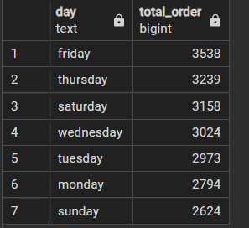

1. **Monthly trend for Orders**

**SELECT TO_CHAR(order_date,'month') AS MONTH,COUNT(DISTINCT(order_id)) AS Total_Order**

**FROM pizza**

**GROUP BY TO_CHAR(order_date,'month')**

**ORDER BY Total_Order DESC**

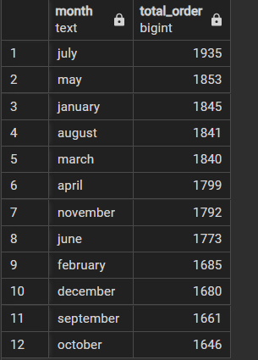

1. **% of sales by Pizza Category**

**SELECT pizza_category,CAST(SUM(total_price)*100/(SELECT SUM(total_price) FROM pizza) AS DECIMAL (10,2)) AS pct_of_sales**

**FROM pizza**

**GROUP BY pizza_category**

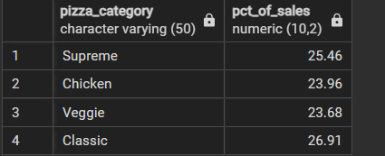

1. **% of sales by Pizza Size**

**SELECT pizza_size,CAST(SUM(total_price)*100/(SELECT SUM(total_price) FROM pizza) AS DECIMAL (10,2)) AS pct_of_sales**

**FROM pizza**

**GROUP BY pizza_size**

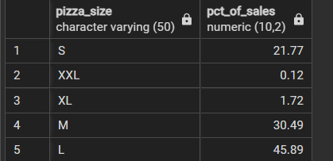

1. **Total Pizzas Sold by Pizza Category**

**SELECT pizza_category, SUM(quantity) AS no_of_pizzas**

**from pizza**

**group by pizza_category**

**ORDER BY no_of_pizzas DESC**

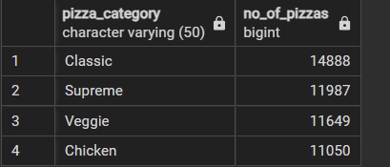

1. **Top 5 Pizzas by Revenue**

**SELECT pizza_name, SUM(total_price) AS Total_Revenue**

**FROM PIZZA**

**GROUP BY pizza_name**

**ORDER BY Total_Revenue DESC**

**LIMIT 5**

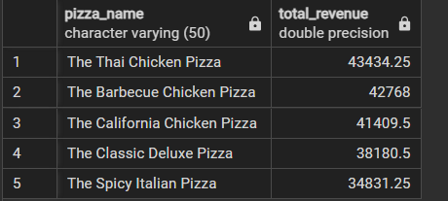

1. **Bottom 5 Pizzas by Revenue**

**SELECT pizza_name, SUM(total_price) AS Total_Revenue**

**FROM PIZZA**

**GROUP BY pizza_name**

**ORDER BY Total_Revenue ASC**

**LIMIT 5**

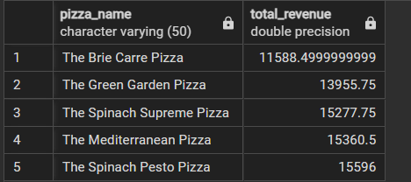

1. **Top 5 Pizzas by Quantity**

**SELECT pizza_name, SUM(quantity) AS Total_Pizza**

**FROM PIZZA**

**GROUP BY pizza_name**

**ORDER BY Total_Pizza DESC**

**LIMIT 5**

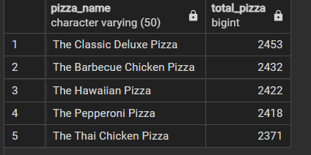

1. **Bottom 5 Pizzas by Quantity**

**SELECT pizza_name, SUM(quantity) AS Total_Pizza**

**FROM PIZZA**

**GROUP BY pizza_name**

**ORDER BY Total_Pizza ASC**

**LIMIT 5**

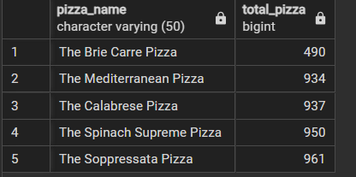

1. **Top 5 pizzas by Total Orders**

**SELECT pizza_name, COUNT(DISTINCT(order_id)) AS Total_Orders**

**FROM PIZZA**

**GROUP BY pizza_name**

**ORDER BY Total_Orders DESC**

**LIMIT 5**

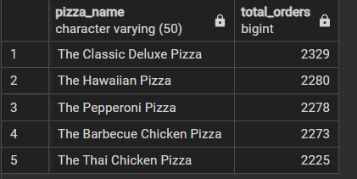

1. **Bottom 5 Pizzas by Total Orders**

**SELECT pizza_name, COUNT(DISTINCT(order_id)) AS Total_Orders**

**FROM PIZZA**

**GROUP BY pizza_name**

**ORDER BY Total_Orders ASC**

**LIMIT 5**

